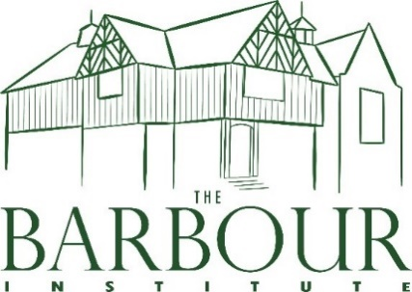
TATTENHALL’S VILLAGE HALL
TATTENHALL COMMUNITY ASSOCIATION
VULNERABLE PERSONS POLICY

- User groups with vulnerable members are encouraged to use ground floor rooms.
- In the event of a fire and if escape is not achievable the vulnerable user is to remain in the building for rescue by the Fire Service. Item 34 Report commissioned by Oldknow Consulting Ltd 13 March 2015.
- Vulnerable persons should not be left alone in the building.

Reviewed Feb 2024

