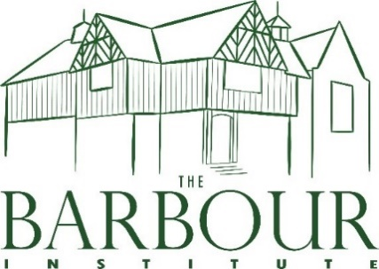
TATTENHALL’S VILLAGE HALL
TATTENHALL COMMUNITY ASSOCIATION
FOOD HYGIENE POLICY
TCA Policy is that a food hygiene qualification is mandatory to work in the kitchen.
- Do not handle food if you have any skin, nose, throat, stomach or bowel trouble or an infected wound.

Keep yourself clean.
- Wear clean clothing.
- Always wash and dry your hands thoroughly:
- Before starting work and after every break
- Before handling food
- After using the toilet
- After handling raw foods –especially raw meats and raw shelled eggs
- After handling waste
- After blowing your nose
- Avoid unnecessary handling of food.
- Tell your Supervisor if you see poor hygiene practices.
- Keep perishable food either refrigerated or piping hot.
- Keep the preparation of raw and cooked food strictly separate.
- Clean as you go to keep all equipment and surfaces clean.
- Follow food safety instructions on food packaging and from your Supervisor.

Remember you must not:
- Smoke, eat or drink in a food room.
- Cough or sneeze over food.
- Prepare food too far in advance of service.
Reviewed Feb 2024

